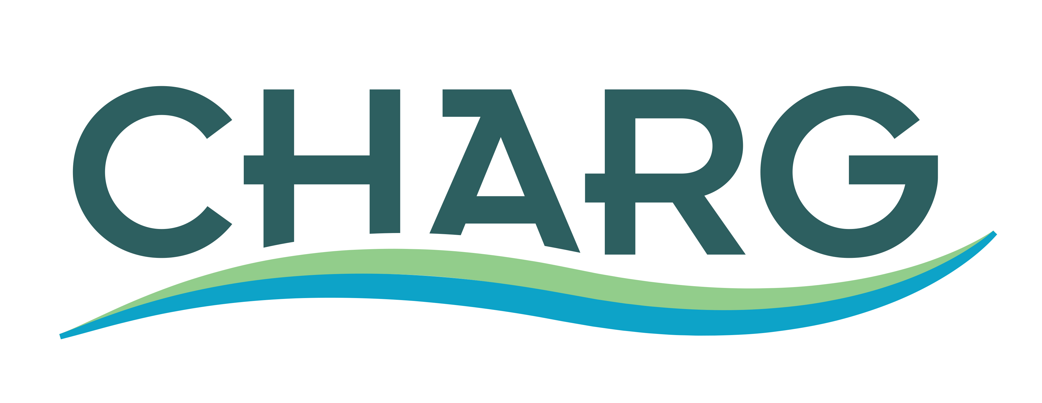

Your name/organization Phone #

SLR Resiliency Projects Map - Project Details Form

Please complete this form (short answers okay, you can leave blank if you don’t know the answer). The details provided will be added to the Map by CHARG. We want to know any work that is being done around SLR resiliency.

- Name of Project Located along Shoreline

- Project Location (city, geospatial coordinates)

- Project Lead / Collaborative Partners? Who is owner?

- Type of Project (Check box)
☐ Study Estimated Year of Completion
☐ Planning Estimated Year of Completion
☐ Design Estimated Year of Completion
☐ Construction Estimated Year of Completion
☐ Other (write in below):

- Is project funded? If so, current funding source(s) (State/Federal/Local grants, taxes, fees etc)

- Total Project Cost (Projected costs through construction)

Additional Project Details

- Technical/Analytical methodologies used (e.g. survey data, Lidar, models, special studies)

- Baseline datum used – circle one: (NAVD 88, NGVD 29, MSL, other)

- Which sea level rise projection did you consider in project design? What design elevation are you building to and why?

- Challenges for project that still need to be addressed (e.g. regulatory, land use, physical constraints, stakeholder issues)

- Are there any technical resources you didn’t have access to which could have improved the development of the project?

- Did this project participate in a regional program and if so which one(s)? (e.g. IRWMP, clean water program)

- Who else may have interest in your project?

- What other benefits will this project achieve beyond flood protection?

- How might this project contribute to a regional solution to sea level rise in the San Francisco Bay?

- Please list any websites or contacts that may be able to provide additional project information

- Please provide any additional information you would like to share about the project.

